To work for master in slave machine:

Created a centos ec2

Open cmd and copy the connect statement. Change the root word in command to centos

Sudo -i

Passwd --- sets a password

vi /etc/ssh/sshd_config

opens the terminal:-- search for password authentication--—change to yes… and remove ‘#’ at permit root login yes.

Password authentication no --- change it to YES

Systemctl restart sshd

Yum install java

In master:

Vi /etc/passwd ---shows all the users connected.

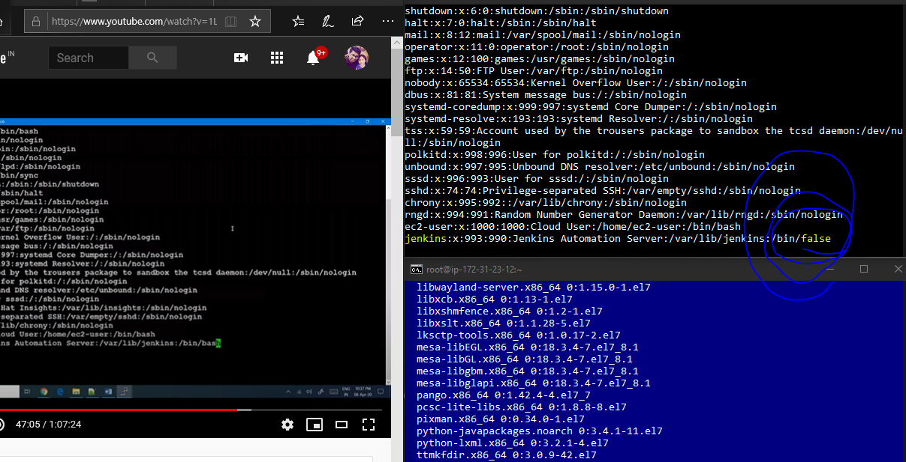

Last jenkins line --- change from /bin/false to bin/bash

Exit from the passwd terminal

su – jenkins ---- logs in as Jenkins user

ssh root@slaveip

**enter the password and slave machine is logged in**

ansible is used to create users and access masters and clients. Ansible gives password less authentication. Jenkins give password authentication.

Ansible cannot provides the poll scm service that is available in Jenkins.

Tool Integrations are not possible in ansible. Jenkins is far more advanced than Ansible.

Jenkins does all the tasks where we can specify when to run the commands and at what conditions

Ansible does not have all the features in Jenkins.

Login to Jenkins (browser)

Manage Jenkins --- jenkins nodes--- we can find the available nodes (currently only master) --- new node --- give a name #devserver1 --- permanent --- OK

Remote root directory - /root

Label - dev (all dev servers come under one group if labelled same)

Launch method : launch agents via ssh

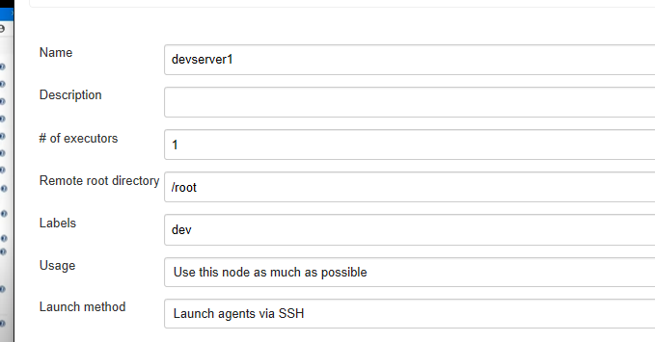

Host: enter slave ip address

Credentials: add – give slave username: root password- 605798 (slave machine pwd)

Description: devserver_root_credentials

Select the credentials to root/ devserver_root_credentials

Hostkey verification strategy: non verifying verification strategy

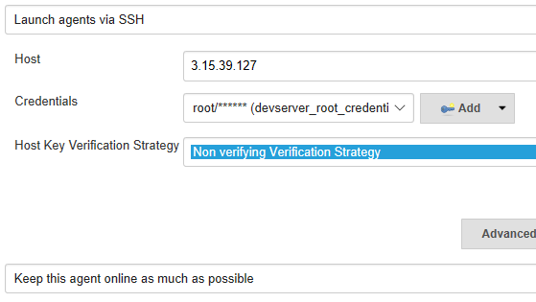

Save it

And check the nodes

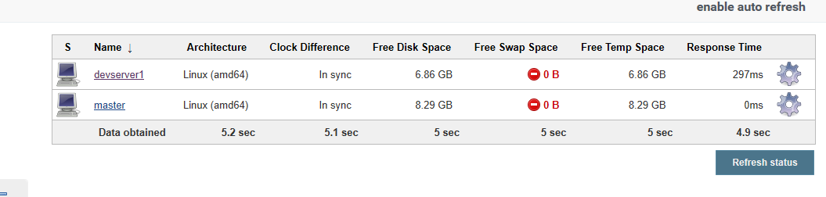

If we don’t configure where the project has to run, Jenkins would automatically take a machine master/slave to run itself

To configure it

Open project test --- configure---restrict where this project can be run (this option is available only if we have multiple nodes) --- select devserver1

Based on the job we need some installations in slave machines

Git is needed in slave machine also to run the tasks

So in slave---- yum install git and make changes in github and wait for Jenkins to trigger